**HTML5 - How We Got Here**

## **HTML History**

Since the early days of the World Wide Web, there have been many versions of HTML:

|  |  |
| --- | --- |
| Year | Version |
| 1989 | Tim Berners-Lee invented www |
| 1991 | Tim Berners-Lee invented HTML |
| 1993 | Dave Raggett drafted HTML+ |
| 1995 | HTML Working Group defined HTML 2.0 |
| 1997 | W3C Recommendation: HTML 3.2 |
| 1999 | W3C Recommendation: HTML 4.01 |
| 2000 | W3C Recommendation: XHTML 1.0 |
| 2008 | WHATWG HTML5 First Public Draft |
| 2012 | WHATWG HTML5 Living Standard |
| 2014 | W3C Recommendation: HTML5 |
| 2016 | W3C Candidate Recommendation: HTML 5.1 |
| 2017 | W3C Recommendation: HTML5.1 2nd Edition |
| 2017 | W3C Recommendation: HTML5.2 |

**New Features of HTML5**

HTML5 offers new elements for better document structure:

|  |  |
| --- | --- |
| Tag | Description |
| [<article>](https://www.w3schools.com/tags/tag_article.asp) | Defines an article in a document |
| [<aside>](https://www.w3schools.com/tags/tag_aside.asp) | Defines content aside from the page content |
| [<bdi>](https://www.w3schools.com/tags/tag_bdi.asp) | Isolates a part of text that might be formatted in a different direction from other text outside it |
| [<details>](https://www.w3schools.com/tags/tag_details.asp) | Defines additional details that the user can view or hide |
| [<dialog>](https://www.w3schools.com/tags/tag_dialog.asp) | Defines a dialog box or window |
| [<figcaption>](https://www.w3schools.com/tags/tag_figcaption.asp) | Defines a caption for a <figure> element |
| [<figure>](https://www.w3schools.com/tags/tag_figure.asp) | Defines self-contained content |
| [<footer>](https://www.w3schools.com/tags/tag_footer.asp) | Defines a footer for a document or section |
| [<header>](https://www.w3schools.com/tags/tag_header.asp) | Defines a header for a document or section |
| [<main>](https://www.w3schools.com/tags/tag_main.asp) | Defines the main content of a document |
| [<mark>](https://www.w3schools.com/tags/tag_mark.asp) | Defines marked/highlighted text |
| [<meter>](https://www.w3schools.com/tags/tag_meter.asp) | Defines a scalar measurement within a known range (a gauge) |
| [<nav>](https://www.w3schools.com/tags/tag_nav.asp) | Defines navigation links |
| [<progress>](https://www.w3schools.com/tags/tag_progress.asp) | Represents the progress of a task |
| [<rp>](https://www.w3schools.com/tags/tag_rp.asp) | Defines what to show in browsers that do not support ruby annotations |
| [<rt>](https://www.w3schools.com/tags/tag_rt.asp) | Defines an explanation/pronunciation of characters (for East Asian typography) |
| [<ruby>](https://www.w3schools.com/tags/tag_ruby.asp) | Defines a ruby annotation (for East Asian typography) |
| [<section>](https://www.w3schools.com/tags/tag_section.asp) | Defines a section in a document |
| [<summary>](https://www.w3schools.com/tags/tag_summary.asp) | Defines a visible heading for a <details> element |
| [<time>](https://www.w3schools.com/tags/tag_time.asp) | Defines a date/time |
| [<wbr>](https://www.w3schools.com/tags/tag_wbr.asp) | Defines a possible line-break |

**New Input Types**

Color, date, datetime, datetime-local, email, month, number, range search, tel, time, url, week.

**New Input Attributes**

autocomplete, autofocus, form, formaction, formenctype, formmethod, formnovalidate, formtarget, height and width list min and max multiple pattern (regexp), placeholder, required, step.

## **HTML5 - New Attribute Syntax**

HTML5 allows four different syntaxes for attributes.

This example demonstrates the different syntaxes used in an <input> tag:

|  |  |
| --- | --- |
| Type | Example |
| Empty | <input type="text" value="John" disabled> |
| Unquoted | <input type="text" value=John> |
| Double-quoted | <input type="text" value="John Doe"> |
| Single-quoted | <input type="text" value='John Doe'> |
|  |  |

In HTML5, all four syntaxes may be used, depending on what is needed for the attribute.

**Current State of Browser Support**

## **HTML5 Browser Support**

HTML5 is supported in all modern browsers.

In addition, all browsers, old and new, automatically handle unrecognized elements as inline elements.

Because of this, you can "teach" older browsers to handle "unknown" HTML elements.

## **Problem With Internet Explorer 8**

You could use the solution described above for all new HTML5 elements.

However, IE8 (and earlier) does not allow styling of unknown elements!

Thankfully, Sjoerd Visscher created the HTML5Shiv! The HTML5Shiv is a JavaScript workaround to enable styling of HTML5 elements in versions of Internet Explorer prior to version 9.

You will require the **HTML5shiv** to provide compatibility for IE Browsers older than IE 9.

## **Syntax For HTML5Shiv**

The HTML5Shiv is placed within the <head> tag

.

The HTML5Shiv is a javascript file that is referenced in a <script> tag.

You should use the HTML5Shiv when you are using the new HTML5 elements such as: <article>, <section>, <aside>, <nav>, <footer>.

You can [download the latest version of HTML5shiv from github](https://github.com/aFarkas/html5shiv) or reference the CDN version at <https://oss.maxcdn.com/libs/html5shiv/3.7.0/html5shiv.js>

### 

### 

### **Syntax**

<head>

<!--[if lt IE 9]>

<script src="/js/html5shiv.js"></script>

<![endif]-->

</head>

**HELLO WORLD**

**Hello World Program using HTML5, CSS, JS**

<!DOCTYPE html>

<html>

<body>

<h2>To Print Hellow World</h2>

<button type="button"

onclick="document.getElementById('demo').innerHTML = Date()">

Click me to display Date and Time.</button>

<p id="demo" style="background: lightgreen"></p>

</body>

</html>

**Output:**

* Before Clicking on button

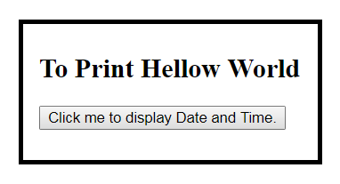

* After Clicking on the button

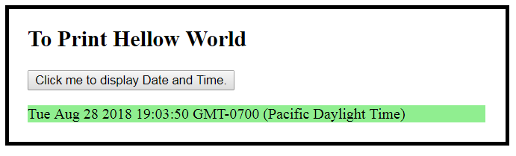

**References**

1. **https://www.w3schools.com/js/default.asp**
2. **https://www.tutorialspoint.com/html_online_training/index.asp**